Contents

Introduction | page 1
Budget | page 2
Who can apply | page 2
Find out more | page 3
How to apply | page 4
Selection process | page 5
Key Dates | page 6
Frequently Asked Questions | page 7
About ‘In Focus’ | page 8
Word Bank | page 9

Introduction
In Focus is a programme run by Photoworks, a charity that works across the UK to promote and develop contemporary photography, supporting artists to make new work and producing exhibitions and events.
It is part of a wider programme called Explorers; comprising awareness-raising activity, commissions, exhibitions, seminars and events developed by Project Art Works in partnership with Photoworks and other cultural partners, with and for neurodivergent communities, placing them at the heart of social, civic and cultural activity.
In Focus commissions support the creation of new work specifically by a neurodivergent adult, including those who may be non-verbal or require complex support.
In Focus also includes photography clubs and public events designed with/for neuro-divergent communities.

The Commission
This commission is an opportunity to make new artwork supported by the Photoworks team. It is specifically for a neuro-divergent adult with varying levels of additional needs, including those who may be non-verbal or require complex support.
The commission is open to individuals for whom photography is central to their artistic practice. We are particularly keen to support individuals who may not have an advocate or platform for their creative work, for example, people who might be isolated from accessing art opportunities. The commission has no theme, and we have no expectation for you to work with people as part of the commission.
The artwork created through this commission will be presented as an exhibition at Aspex Portsmouth, who are kindly supporting In Focus as a partner.
Applicants must be based in within reasonable travelling distance of Portsmouth.

Accessibility
If you require an Easy Read version of this document, please contact Ricardo Reverón Blanco at Photoworks: 07955401992

Note, if you are the support worker, family member or similar, reading this on behalf of the person you support, please replace ‘you’/’your’ with the phrase ‘the person you support’.

There is a word bank at the end of this document that you may find useful.

Budget
All costs associated with developing ideas and producing new artwork and exhibition will be covered. Funds can support an individual in a number of ways, either as a fee or paying for support workers time, transport, materials or more indirectly through support teams/families. We understand every individual has unique financial circumstances that need to be addressed. The aim of financial support for this commission is to protect and promote a person’s ability to make art without affecting their package of support.
Photoworks will work with you to identify what it will cost for you to realise your ideas and put together a budget with you (within a given limit).
Additional funds are available to provide creative support or mentoring throughout the commission process.
Fee: £3000 (including VAT)

Who is eligible to apply?
There are no educational requirements.

You must be over 18 years of age.

The project should include or be related to photography.

Ideally you will live in one of these counties: Hampshire, West Sussex, Wiltshire, Surrey, OR be within reasonable travelling distance of Portsmouth.

Want to find out more?
If you are unsure if you would like to apply, we will be running face to face Information & Support Sessions where you can come and find out more.
You can register for a 15 minute one to one session with a member of the team where you can ask any questions you have about making an application.
To register for your individual session, please email ricardo@photoworks.org.uk
Unfortunately, we are unable to cover any travel expenses to these events.
If you are unable to attend a session in person, then we can arrange a phone or video call instead. Please email ricardo@photoworks.org.uk

How to Apply

Please send us your application by writing, video, or audio recording (see details below). Please ensure you include the following information:

- Tell us your name, address and postcode.
- Let us know that you self-identify or are identified by others as neurodivergent.
- Explain any specific support needs you have that we should be aware of.
- Confirm that you are over 18 years old.
- Tell us your idea for the commission.
- Explain how this commission would help you to achieve that.
- Describe how the opportunity will benefit your artistic development.
- Tell us why you like making art with photography.
- Share with us up to 10 images of past examples of your photography artwork.
- Complete the anonymous equal opportunities monitoring form on the Photoworks website.

How to send us your application

- In writing:
Please complete the application form on the Photoworks website.

- By video or audio recording:
Please make sure the recordings are no longer than 5 minutes in length. Please note that production values will not be taken into account.

You can send large files to us using WeTransfer. Go to wetransfer.com and follow the instructions. Email your files to: ricardo@photoworks.org.uk Please also send Ricardo any supporting information.

- Please also complete the equal opportunities monitoring form on the Photoworks website.

If you do not have internet access or have any queries with the application methods, please contact Ricardo Reverón Blanco at Photoworks either by email: ricardo@photoworks.org.uk or by calling 07955401992.

Deadline for applications: 10am, Monday 24 October 2022
Notification if shortlisted: Monday 31 October 2022
Photoworks is an equal opportunities employer. Please let us know in your application what we would need to put in place to ensure that any access requirements you have are met through the selection process.

Selection

Staff at Photoworks and Aspex Portsmouth will be looking through all the applications and deciding on a shortlist of four people.

Photoworks has skills in photography and working with people/artists to make new work. We are looking for people that show an interest in photography where Photoworks could help progress their practice.

If you are not shortlisted, a member of Photoworks will notify you and your support worker by email.

Shortlisted candidates

Photoworks will not be conducting formal interviews for this commission. Instead, the four shortlisted candidates will be asked if we can visit them either in their studio if they have one, or at home or a setting they feel most comfortable in.

You can have your care or support worker with you throughout. We will visit you for no longer than an hour and will ask to see some artwork that you may have made in the recent past. We will also ask you some more questions about your ideas for the commission.

If you are unsuccessful, then a member of the Photoworks team will call you or your identified support person and have a conversation to share constructive feedback.
Key Dates

Deadline for applications | 10am, Monday 24 October 2022
Shortlist selection notified | Monday 31 October 2022
Home or studio visits for shortlisted candidates by staff from Photoworks and Aspex Portsmouth teams. | 3, 4, 7 November 2022
Final selection | 11 November 2022
First commission meeting with Photoworks team | TBC
Making period (with mentoring and support) | November 2022 – August 2023
Presentation of final work (digital portfolio, in time for Project Art Works publication deadlines) | 1 September 2023
Presentation of final work (exhibition at Aspex Portsmouth) to include public programme of talks & events. | Spring 24 (dates provisional)  Friday 12th April (PV on 11th April) - 30th June 2024
Project Art Works Publication | Late 2023
Feature in Photoworks Festival 2024 | October 2024

Frequently Asked Questions

If I am shortlisted, who will visit me?
Home or studio visits will be made by the following people:
Ricardo Reverón Blanco, Project Manager, Photoworks
and Vickie Fear, Curator/Programme Manager, Aspex Portsmouth
We will let you know if this changes so that you know who to expect.

If I am selected, who will support me through my commission?
This commission is all about providing the support you need to make work. Provision will depend on your specific support requirements, and we will discuss it with you should you be selected.

My support worker is not an artist, will I receive any access to artist mentoring?
Photoworks will assess this based on your specific application but will aim to provide some artist mentoring throughout the process.

What is a mentor?
A mentor is an experienced and trusted advisor. We will help match you with somebody that has skills and experience that will benefit you and your work.

A fee will disrupt my PIP payments, what can I do?
We will look at alternative methods of ensuring costs are covered and you have the financial support needed to successfully complete the commission.

Who will help me manage the budget?
Ricardo Reverón Blanco at Photoworks will support you with this.

About In Focus

In Focus is the Photoworks project that is part of a wider programme called Explorers; comprising awareness-raising activity, commissions, exhibitions, seminars, and events developed by Project Art Works in partnership with Photoworks and other cultural partners. The programme is developed with and for neuro-divergent communities, placing them at the heart of social, civic, and cultural activity.
Find out more about the programme at photoworks.org.uk/explorers/

About Project Art Works

Project Art Works is the UK’s leading visual artist-led organisation working with people who have complex needs and the people, systems and services that support them. We run a regular year-round programme from our studios in Hastings and in the region for adults, young people, children and families. We also collaborate with major cultural venues from across the UK to put on exhibitions and other inclusive cultural events.

Established in 1997, Project Art Works has worked with thousands of people with complex needs and continues to offer advocacy, support and friendship to them and their families. For more information visit projectartworks.org

About Photoworks
Photoworks champions photography for everyone. We are an international platform, global in reach, and have provided opportunities for artists and audiences since 1995. We do not have a physical venue, but our online channels are always open. Our programme brings new experiences to audiences and opens up new ways to encounter photography.
Photoworks is a registered charity and the only organisation with a national remit for photography in England. Our work is supported by public funding through Arts Council England’s National Portfolio. Photoworks is led by Shoair Mavlian, Director. For more information visit photoworks.org.uk
About Aspex Portsmouth
Aspex exists to support emerging artists, reveal the creative process, and engage new audiences with visual art. We achieve this by delivering an exciting and varied programme of exhibitions, off-site projects and participation events. Our aim is to make the creation and enjoyment of art a more inclusive activity.
For over 40 years, we have supported sensational artists at the early stages of their careers. Artists such as Mona Hatoum, Richard Wilson and Susan Collis, all now internationally-acclaimed, received support from Aspex. Today, we continue to offer the next generation of contemporary visual artists a platform from which to launch their careers. For more information visit aspex.org.uk

Word Bank

Artist (or Maker) | Someone who makes art  You do not need to call yourself an artist, and you do not need to make art full time to take part in our commission
Artwork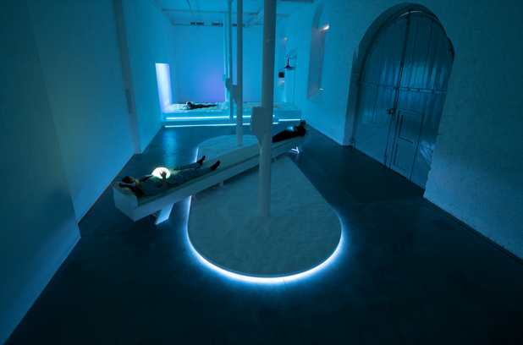 | An artwork can be something you see, hear, touch or feel, which can express a specific idea or feeling
Additional Needs / Complex Support Needs | Someone who needs support from other people to be able to live their life as fully as possible
Commission | An agreement between an artist and an organisation to make some art for a specific place or time
Exhibition  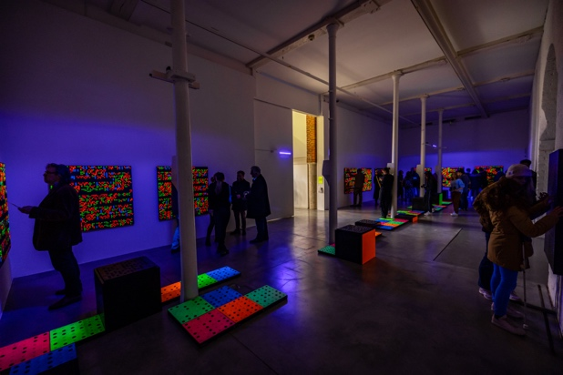 | A sharing of art with other people
Mentor | An artist or other experienced professional who can support you in successfully achieving your artistic ideas
Neurodiversity | The idea that everyone in the world thinks differently
Neuro-divergent | Someone who may think in a different way to most people
Non-verbal | Someone who does not use spoken language to communicate
Photoworks | An arts charity in Brighton that supports people to make and enjoy photography
Photographer  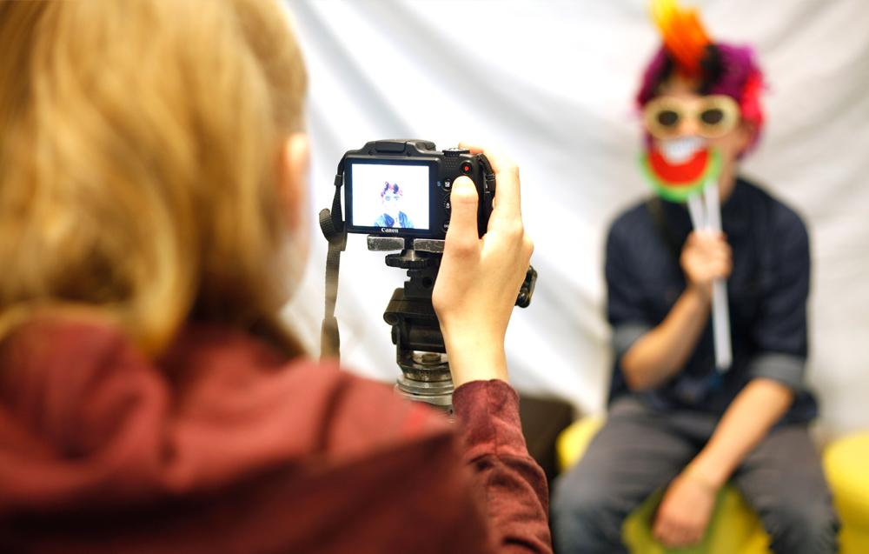 | At Photoworks, we work with artists who make photographic images

Images of Aspex and image taken by Lindsey Smith (in order of appearance)

