

**Photoworks announce *Multi multi,* Photoworks Annual # 31**

*“...the mass reproduction of photographic images in books only became possible in the very specific conditions of the late nineteenth century and early twentieth century…”* Michelle Henning, *Photography: The Unfettered Image*

Multi multi, Photoworks’ 31st Annual , is a deep dive into image replication which launches at Photoworks Weekender on Friday 25th October and in Paris, in November.

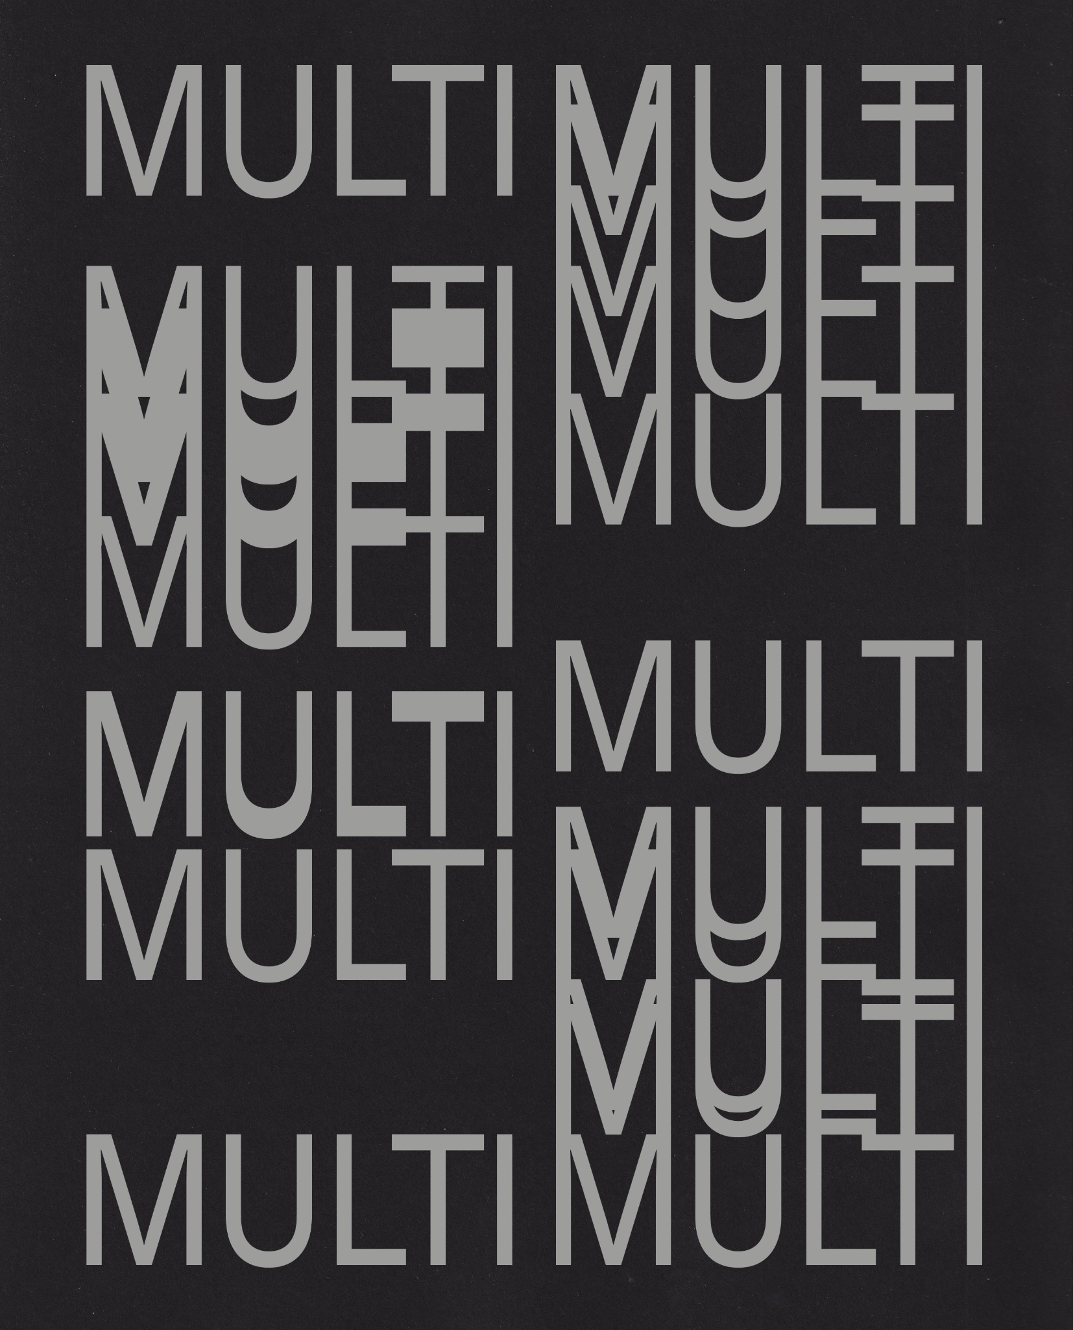

Cover design by Shaz Madani

William Henry Fox Talbot pioneered photomechanical reproduction in the 1840s, and Walter Benjamin published his iconic essay The Work of Art in the Age of Mechanical Reproduction, in 1935. But since then, the implications of photography’s reproducibility have been largely ignored - and even deliberately suppressed in limited edition fine art prints. That is, until now. The invention of digital imaging, the internet, and social media have brought the ability to reproduce and circulate images to the fore, and with them new questions around what it all means. Michelle Henning’s Photography: The Unfettered Image and Andrew Dewdney’s Forget Photography propose images as part of a flow, while developments in AI suggest attempts to create order from chaos.

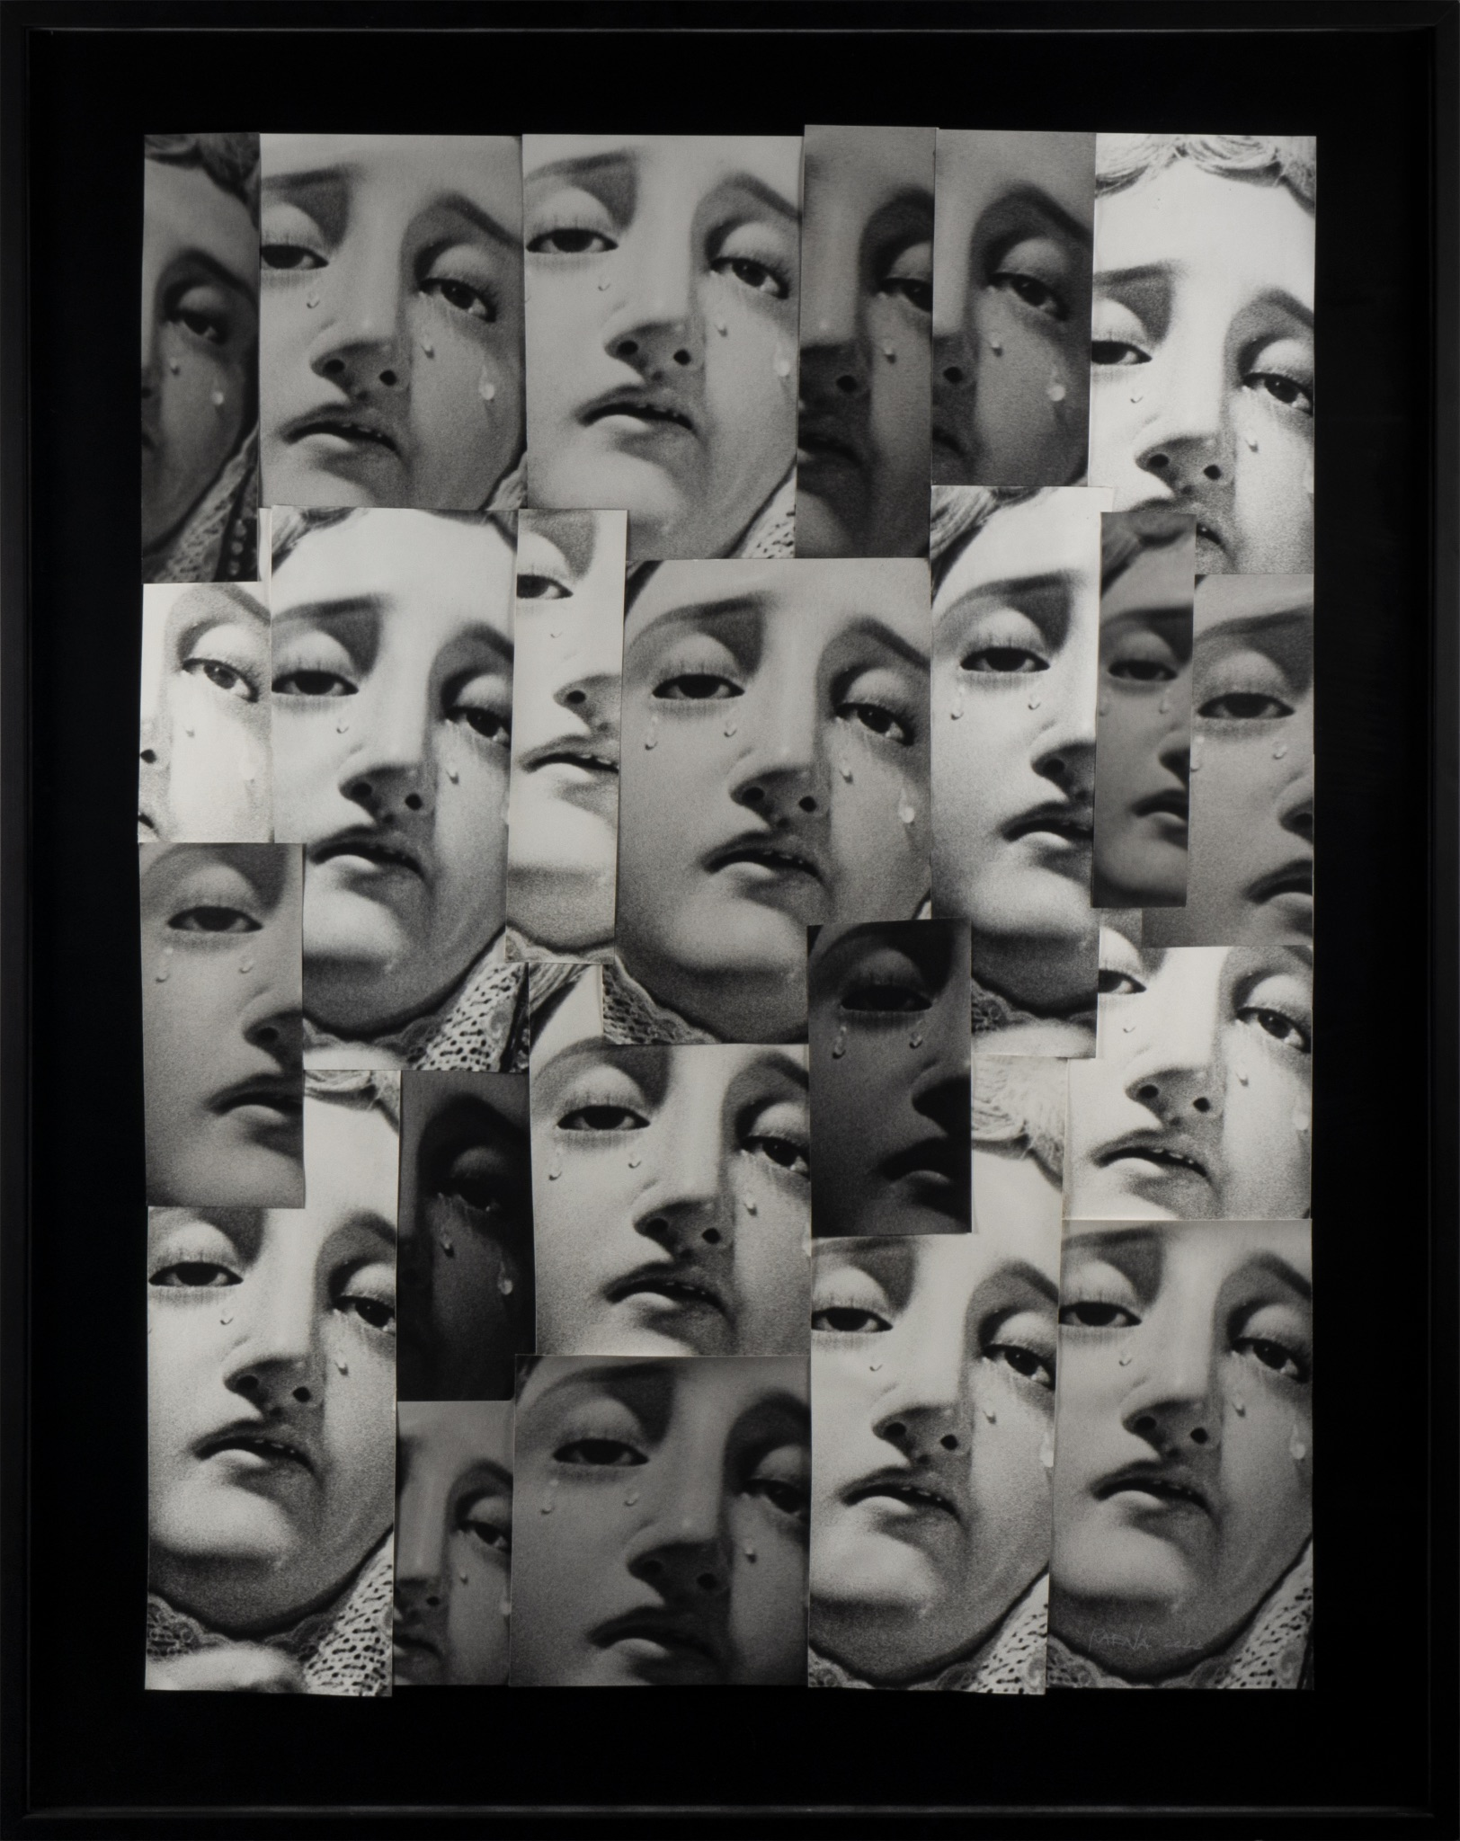

© Raena Abella, *Faces of Grief,* July 2024

Multi Multi (Photoworks Annual # 31) gathers contemporary artists working with replication, in 23 projects by image-makers from around the world. Mixing projects made with cutting-edge technology with works created with the oldest analogue processes, it suggests that image replication is nothing new. In doing so, Multi Multi suggests image replication is intrinsically linked to the culture in which it was born, at the start of industrial capitalism. Multi Multi continues the project begun with Photoworks Annual 30, The Thing, which considers how images extract and commodify; it just asks what happens when they’re mass produced.

Designed by Shaz Madani, Multi Multi is a printed publication, featuring 23 projects by artists from around the world. It also includes essays by Andrew Dewdney and Michelle Henning, and an experimental text created with AI by Alex Puliatti, who recently graduated from King’s College London. Multi Multi includes an introduction by Photoworks editor Diane Smyth.

**Featured artists include** Paul Mpagi Sepuya, Juno x GERIKO, Scheltens & Abbenes, Lunga Ntila, Cai Dongdong, Jasleen Kaur, Zou Jingyao, Yuxing Chen, Louisa Clement

Jason Grant and Oliver Vodeb, Chuan-Lun Wu, Marcel Top, Armin Linke and Estelle Blaschke, Felicity Hammond, Thomas Sauvin and Max Pinckers , Anna Ridler, Kurt Caviezel, Ton Grote, Raena Abella, Sayako Sugawara, Luis Cobelo, Hoda Afshar

Lewis Bush.

**Featured essays are by** Andrew Dewdney, Michelle Henning and Alex Puliatti.

The Annual is available for free to Photoworks Friends, or £35 in selected art bookshops

**Photoworks Annual #31: Multi Multi will launch at Photoworks Weekender at the Old Courthouse, Brighton Friday 25th October at 5.30-7.30pm - the event will feature a discussion led by Photoworks and Multi Multi Editor Diane Smyth together with contributors from the publication Michelle Henning, Felicity Hammond, Yuxing Chen.**

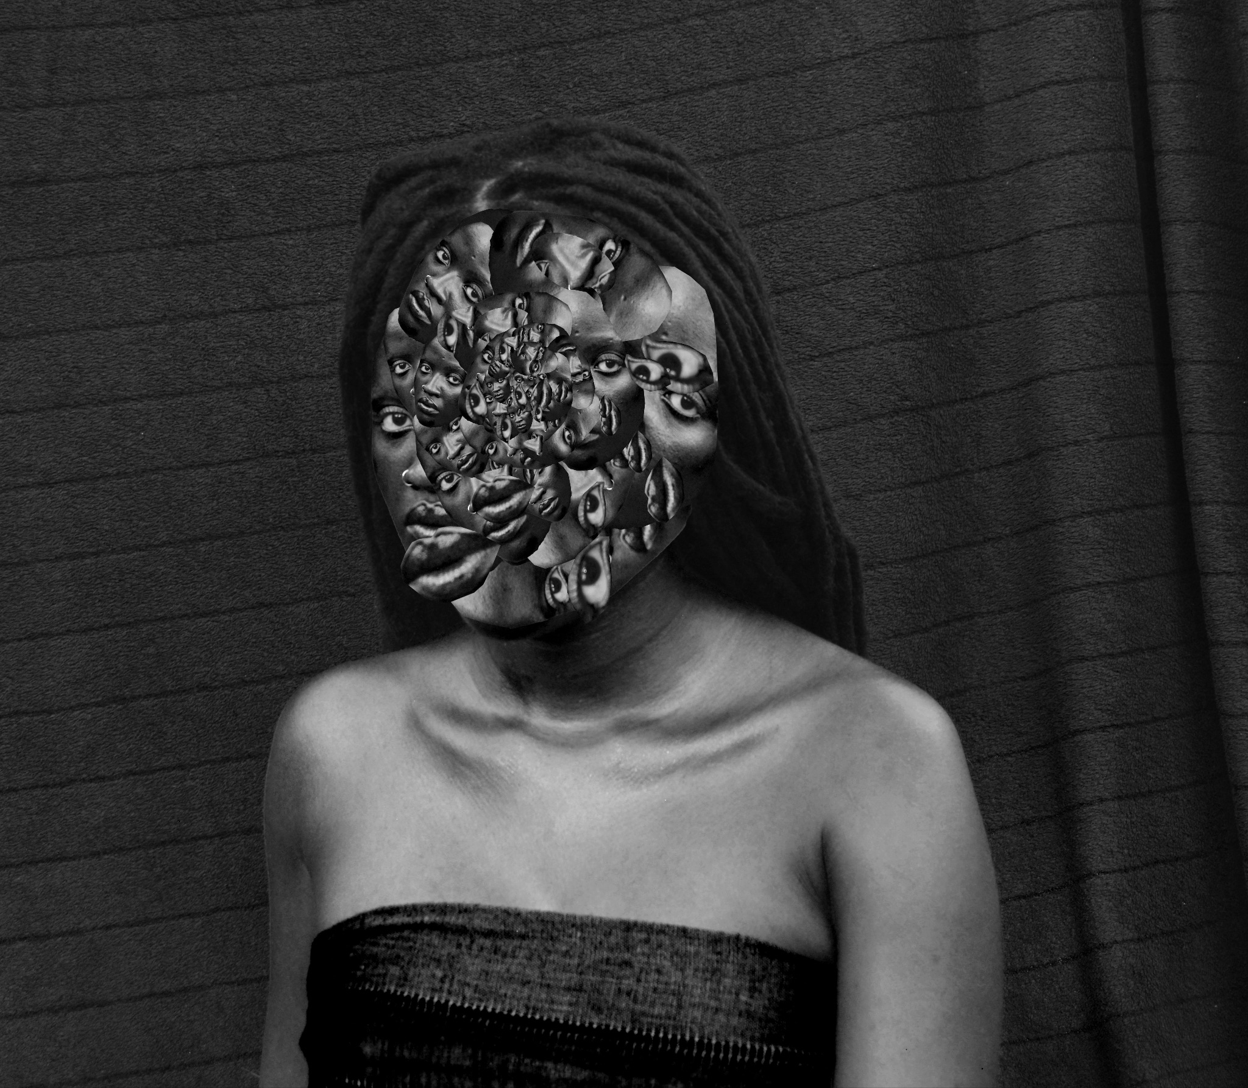

Lunga: © Lunga Ntila, *Arising of Sanity*, 2020

**For media information contact:**

Nicola Jeffs

[nj@nicolajeffs.com](mailto:nj@nicolajeffs.com)

07794 694 754

**Photoworks**

Photoworks champions photography for everyone. We are an international platform, global in reach, and have provided opportunities for artists and audiences since 1995. Our programme brings new experiences to audiences and opens up new ways to encounter photography including the Photoworks Festival (next festival 2026). Photoworks is a registered charity and the only organisation with a national remit for photography in England. Our work is supported by public funding through Arts Council England’s National Portfolio.

photoworks.org.uk

@photoworks_uk

**Other events for Photoworks Weekender, include, with more to be announced taking place 24-27 October:**

* A new two day intensive professional development programme, **Superlab,** by **Photo Meet/Photoworks**, a series of masterclasses led by leading photography experts exploring exhibitions, editorial, photobooks and commercial practices, taking place 25-26 october at the University of Brighton.
* **Exhibitions at University of Brighton, Edward Street** - featuring a curated selection of photobooks; the work of PhotoMeet 2024 Award winnersSabine Hess, Keerthana Kunnath, and Imogen Forte; Peer Matters, an exhibition by 15 contemporary photographers; and more.
* **Photoworks PhotoSocials** for artists, curators and makers to meet and network through workshops, roundtables and interactive sessions.
* Launch of Lauren Joy Kennett's inaugural publication ***Sorry I’m not sorry*** designed and published by Jane & Jeremy, produced by Photoworks and supported by Project Artworks. This launch event is presented as part of Photo Fringe, alongside the launch of Cole Flynn Quirke's new book, also designed and published by Jane & Jeremy
* A further programme of curated talks and events and tickets go on sale at the end of the summer.